Compact Vibrating Fork Type Liquid level switch is a simple, low cost, rugged point Level Switch designed for Level detection of liquids in a tank or vessel. This level switch can be used for detecting high, mid or low or for both level detection. Used in oil industries, Paint Industries, food processing plants, beverages, chemical industry, pulp/paper industry, pharmaceuticals industry etc.
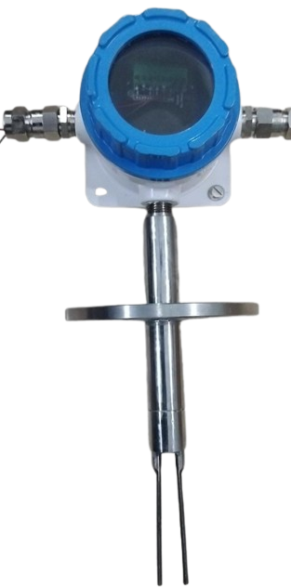
The unit has integral electronics along with sensitivity adjustment and time delay feature, LED indication, fail safe logic etc.

SALIENT FEATURES
Probe Construction suitable for Liquid applications: Basically, the Liquid Vibrating fork type instruments are used for Level detection in Resins, water, oil, acids, chemicals etc. when the media/ liquid level reaches up to the Vibrating fork/ probe,
The vibrations of the fork are damped because of the liquid in contact, and sensing signal reached to connected electronics circuitry and generates a switching signal to relay circuit integrated with timer functions. The fork vibrates at vibrating frequency of 350 Hz (±10Hz


- Wide range of application
- Easy installation and maintenance.
- Weatherproof/Flameproof enclosure as per requirement
- SS 316 Vibrating Fork to withstand in harsh environments.
- Adjustable differential time delay with ON/OFF timing.
- Fail Safe High/Low Selection Feature (Field configurable)
- Sensitivity adjustments as per application media.

M/S. Levtron Instruments Pvt Ltd.
Office No 2, 1st floor, plot no 6, Pandhari Industrial estate, Shivane.Pune411023,
Contact:09579430012/9730042725, E-mail:sales@levtron.in,Web:www.Levtron.in

Model: VFLS-700L F
Make: Levtron Instruments Pvt Ltd. Pune

Technical Specifications

SUPPLY VOLTAGE OUTPUT TYPE CONTACT RATING CABLE ENTRY TEMPERATURE

Type
Probe Length MATERIAL
Enclosure

MOUNTING
FREQUENCY
TIME DELAY

FAIL SAFE

24V DC (factory selectable)
- x DPDT Relay
05 AMPS at 230VAC /24VDC,
- X ½” NPT, (others, Specify)
0-250°C for integral type.
(Design temp 300°C)
: Flameproof Integral Probe.
: 300 MM or as per requirement, specify.
Sensing Fork: SS316, Flange: SSS304.
: Cast Aluminum IP 68 Flameproof
80 NB Flanged 150#. weatherproof as (optional)
350 Hz (+/- 10%)
0 To 20 seconds adjustable with ON/OFF delay Selection
Field Selectable.

